
SLR Newsletter

Winter 2016
www.stokelodgeramblers.wordpress.com
Dear Members,
Following the AGM the Committee has met to plan the year and we hope to maintain and enhance the programme of activities. First a big thank you to the Committee who volunteer to lead so many of the walks and manage the administration. For those of you who have not been on the website recently you are missing a treat. Sue Hazelden and Sue O’Hara have taken Neville’s excellent work and enhanced it further with lots of photographs to help you remember days walking in the sunshine (and the wet) as well as carrying amusing tales of the various events we have arranged. The News Update section is particularly useful in letting us know of changes to planned walks and all are advised to look this up (or phone a friend who is IT savvy) before venturing out on a Thursday or Sunday. Sue reports our finances to be in a healthy state and some 85 members have paid their £8 membership fee for the next year. If you are one of the small number who have yet to renew your membership please let Sue have the money as soon as possible.

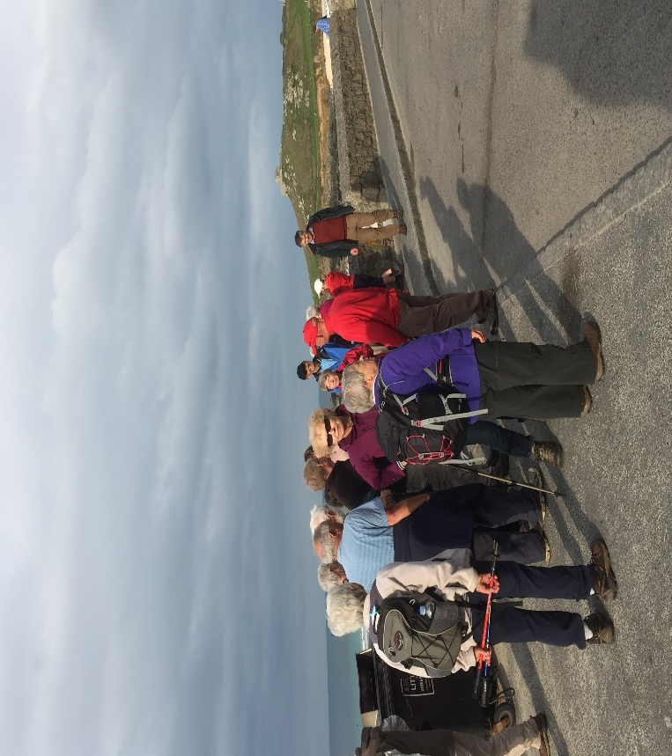

The Walks Programme for Spring / Summer 2017 (enclosed with this update) looks very promising and thanks to all walks leaders who have volunteered to lead walks. On 5th February I hope to lead a walk of some 7 miles locally starting from Cross Elms as usual at 9.30 am which will have dual purpose: first to enjoy company on a usual Sunday walk, but also to offer training in route-finding using a map and compass to those who may wish to develop skills in order to gain confidence to lead future walks.
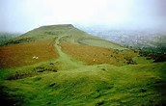
Thanks to Dick and Jenny Dennett we have a New Year’s Day walk and meal at 'The Old Royal Ship', Luckington, (near Badminton, Exp 168, GR 834842). Meeting 10 am at Cross Elms, there is a 5 mile walk. Please be sure to contact Dick or Jenny and sign up BEFORE 15th December to allow places to be booked for lunch.
Our Spring Social event is on Saturday 1st April 2017, at St Mary's Church Hall in Stoke Bishop. Be sure to note this date in your diary as we have Peter Davey, Chairman of the Clifton Rocks Railway, to speak to us about this fascinating underground excavation that is under the Avon Gorge Hotel where we are holding the Christmas meal.
For those of us who went to St Ives we have glorious memories of sun shining over the sea in St Ives Bay and glorious walks along the coast and to St Michael’s Mount. Next year’s October weekend away is planned for Friday 13th to Monday 16th October 2017 and will be based at a hotel in or near Crickhowell (details tbc). Secret Hills are already planning out routes (and taking notes of comments made from St Ives) to ensure there is something exciting for all classes of walkers. Gentle walks along the Brecon Canal and river Usk with more adventurous climbs up Table Mountain, The Sugar Loaf or around Llanthony Priory are being explored. We hope to be able to confirm prices at the Christmas Lunch and request a £50 per person deposit to be made before Christmas.
Finally, we welcome the following new members: Hilda Ball (who joined late last year), Denyse Gaujoux, Paul Hazelden, and John & Gloria Isaacs.
Best wishes for a wonderful Christmas and great year’s walking in 2017
David McGregor

